Mikulás Rallye ’2015 with licence
5-6th december 2015. amateur

Postal address: Laroco MSC H-8200. Veszprem Gabor Á u. 2/c Hungary
Closing date for entries: 26th november 2015.
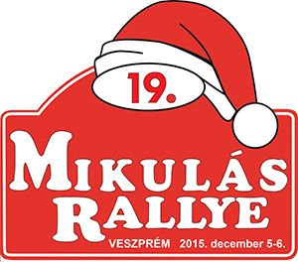

ENTRY FORM
 | Entrant | DRIVER | CO-DRIVER
NAME:
Address:
Telephone No. and e-mail address:

Licence No.:
Type of the licence and date of issuing: | 2011-2013.  2014.  2015. | Rally Off-Road  Other
Driving licence No.: | -

Organiser won’t send any confirmation from the entries! For informations please visite the Rally’s official website: www.mikulasrallye.hu.

DETAILS OF THE CAR:
Make: | Types: | Chassis No.: | Group:
Cylinder capacity: | FIA homologation No.: | Registration No.: | Class:

We, the undersigned, have read and understood the rules of the Regulations and agree to strictly observe them during the entire duration of the Rally. We confirm that the contetnts of this Entry are true and correct and the entered car and its components fully correspond to the provisions of the supplementary regulations. We declare, that we entered for the Rally by our own volition, and we participate on it for our liability.

Entrant’s sign or stamp | Driver’s sign: | Co-driver’s sign:

Date: | Adress of the bill from the entry fee and insurance:
Following boxes filled by the Organiser!
Csoport: |  | Géposztály: |  | Rajtszám:

Nevezés beérkezett: | Nevezési díj befizetve: | Itiner kiadva: |  | Nevezés elutasítva:
1./ Rajtszámok | 2./ Rallye táblák | 3./ Menetlevél | 4./ ….. sz. végr.utasítás | 5./ Rendezői reklámok
Az adminisztratív átvétel dátuma és ideje:  Az adminisztratív átvételt végző aláírása: |  | Az 1./-5./ alatti dokumentumokat átvettem:  Versenyző aláírása:

