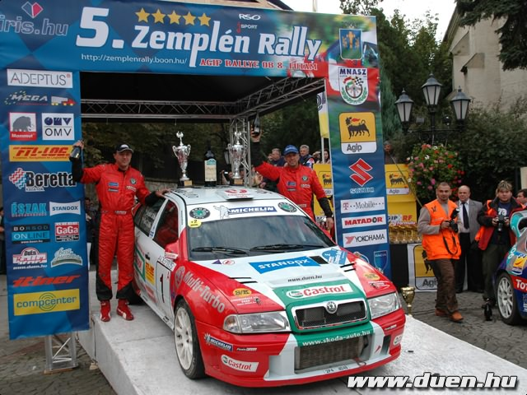

TURI
RALLY
TEAM

